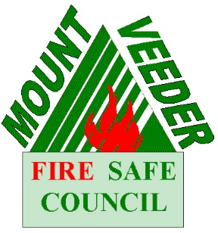
Mount Veeder Fire Safe Council
Neighbors in Need
Defensible Space Assistance Program

QUALIFICATION GUIDELINES

- Applicants must be residents of the Mt. Veeder Fire Safe Council (MVFSC) area who are in need of assistance as determined by the MVFSC. Factors can include age, disability, or income.

- Inspection and contract coordination are free of charge to those approved by MVFSC.

- If the applicant is not the property owner, the property owner’s approval, signature, and possibly financial information will be required before work can be performed on the property

- Work will not be performed on a neighboring parcel that is located less than 100 feet from the house that is the subject of the application

- The property must not currently meet the standards of Napa County Resolution No. 08-45 which requires a minimum of a 100 foot clearance of all flammable materials (needles, dry grass, brush, etc.) around the house and also fuel reduction to 100 feet (or to the property line).

- All work through the assistance program will be accomplished by a contractor retained by Mount Veeder Fire Safe Council. The work will be completed as close as possible to Napa County Resolution No. 08-45.

Mount Veeder Fire Safe Council
Neighbors in Need
Defensible Space Assistance Program

APPLICATION

Applicant: _______________________________________ Are you the property owner? YES ☐ NO ☐

Property Owner: _____________________________________

Property Address: ____________________________________

Parcel number: _______________________________________

Phone number: ________________________________

Email address: _________________________________

What assistance do you need in clearing defensible space?

_________________________________________________________________________________________

_________________________________________________________________________________________

_________________________________________________________________________________________

_________________________________________________________________________________________

_________________________________________________________________________________________
I certify that the information on this form is correct and true. All requirements in this application/contract will be followed if assistance is received from Mount Veeder Fire Safe Council.
I understand that this is only an application for assistance. I understand that the Mount Veeder Fire Safe Council will determine whether to have work performed on my property based on the determination by the MVFSC.
Applicant Signature: _______________________________________ Date: _________________
Owner Signature: _______________________________________ Date: _________________
(if not owner-occupied)
Submit application via US Mail or email (include Neighbors in Need Program in subject line) to:
Neighbors in Need Defensible Space Assistance Program
Mount Veeder Fire Safe Council
PMB 715
4225 Solano Ave
Napa, CA 94558
mtveederfiresafe@gmail.com

